**Academic Check-in: How to Check Grades**

Here is how to check grades for any student currently enrolled in one of your courses.

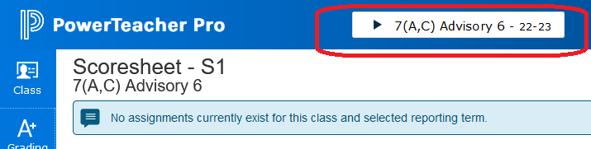

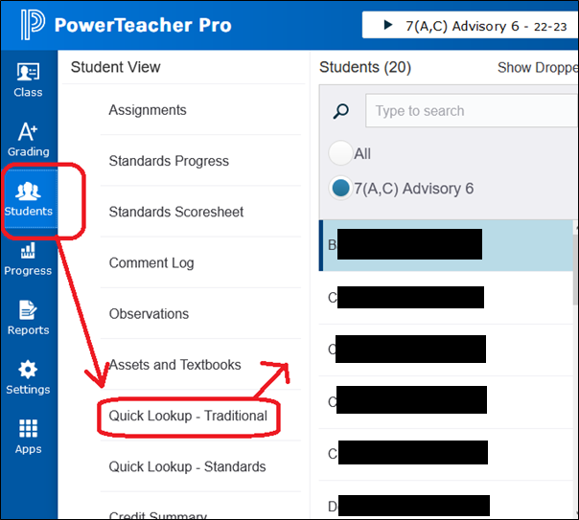

This will take you to a page with all their semester grades.

Click on one of the grades and you can see every assignment grade for that course. ↓

